**Example uses of Matpulse**

**Overview:**

Example 1 provides a straightforward example for an improved spectroscopy excitation pulse. Example 2 provides a more sophisticated use of MatPulse for generation of a short spin echo pulse for observation of relatively short T2 relaxation. These examples are chosen to illustrate some of the capabilities in MatPulse and do not necessarily represent pulses that would be useful on a particular MRI instrument.

**Example 1:** Improved rejection band spectroscopy pulse for improved suppression of “out of volume” (lipid) contamination in the head.

In this example we suppose that the user experiences lipid contamination in a spectroscopy voxel that is not entirely eliminated by outer volume suppression, or wishes to eliminate the use of outer volume suppression pulses (e.g., to avoid SAR constraints and use shorter TR). In addition, the user may want to improve the selectivity of the pulse profile. We further assume the user is willing to use a pulse slightly longer than the original pulse to achieve the improved performance.

**Assumptions on instrumentation:**

We assume this is a Siemens system, so that in the Master Parameters the user will set the Zero Padding to 2. We also assume the B1 maximum (B1max) for the system is around 20 uT.

**Pulse Design:**

Exploration of various 90 degree pulses in the Pulse Generation menu shows that a 4 ms, 3 kHz pulse has an excellent profile, and has a B1max of just under 20 T. If the voxel is not to be placed too close to lipid at the edge of the skull, the user may want to use Least Squares Filter Function (under the Master Parameters menu) as this generates a pulse profile whose rejection increases with distance from the edge of the profile (as opposed to an equal ripple pulse whose rejection is constant). While the figures produced by the SLR Pulse Generation menu are approximate, the Bloch Equations figures are completely accurate. Using 250 points (User Input) and a time of 4 ms, with a width of 3 kHz, a Passband Ripple of 5, and a Rejectionband Ripple of 0.1 to generate a pulse from the SLR Pulse Generation menu (with other parameters left at their default values), yields the following figures from the Bloch Equations menu.

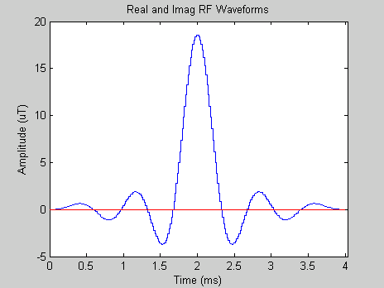 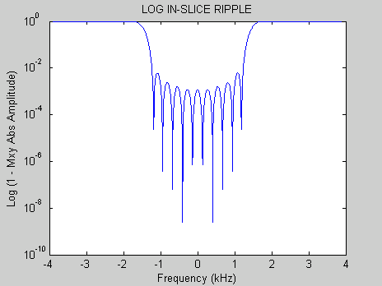 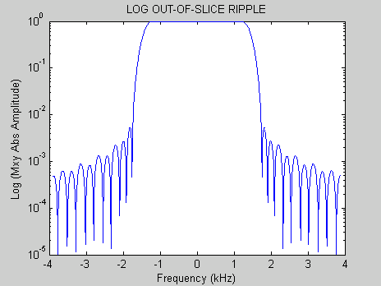

Fig. 1. RF pulse. Fig. 2. Passband ripple. Fig. 3. Rejectionband ripple.

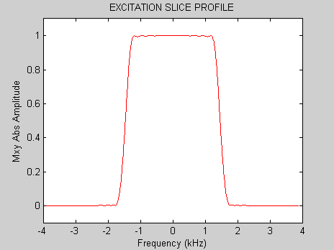 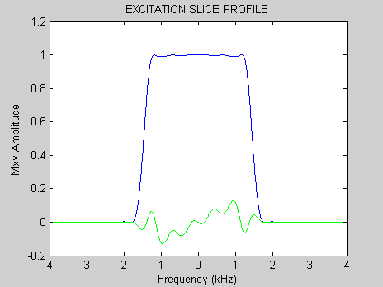 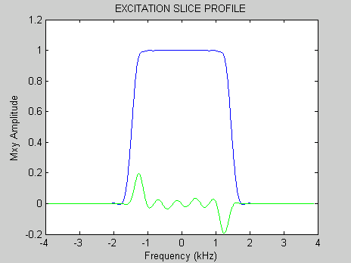

Fig. 4. Magnitude profile. Fig. 5. Default refocused profile. Fig. 6. Optimized refocused profile.

Figure 1 shows that the zero padding is automatically inserted into the pulse. Figure 2 shows the passband ripple, while Fig. 3 shows that the rejection exceeds 10-3 a short distance from the edge of the profile. Figure 4 shows the excellent magnitude profile, while Fig. 5 shows the real and imaginary profile components with the default gradient refocusing (-0.5155) , and Fig. 6 shows that the optimal refocusing from the Gradient Refocusing menu is -.5075, where -0.5 represents the usual gradient refocusing. It is worth noting that although the ripple amplitude settings are fairly accurate for the equal ripple pulses, they are only a rough guide for the least squares-designed pulses. For example, although Fig. 2 shows the passband ripple to be 1% or less, although the value entered in the pulse design menu was 5%.

The pulse may then be saved with the Siemens Save menu and imported into a new sequence with the Siemens Pulse Tool program (part of the Siemens IDEA pulse programming language). Should contamination persist, a pulse with still greater suppression can be designed, although at the expense of either larger transition bands or longer pulse length. Although still greater suppression can be designed into the pulse, small errors in the pulse implementation (such as non-linearity in the RF pulse amplifier) can degrade the fidelity of the pulse and prevent the designed suppression from being achieved.

**Example 2:** Generation of a short spin echo pulse for observation of relatively short T2 relaxation.

The literature suggests that some brain tissues exhibit a double exponential T2 relaxation, with the short T2 component between 5 and 10 ms, and a long component nearly an order of magnitude longer (between 50 and 100 ms). A short spin echo pulse of under 2 ms length is desired to obtain T2 data that captures the short T2 component. Finally, we assume the pulse will be slice selective to excite a slab of 100 mm, and that at high field resonance offsets exceeding 100 Hz are expected.

**Assumptions on instrumentation:**

We assume this is a high field Siemens system. We also assume the B1 maximum (B1max) for the system is around 20 T. Additional parameters include a slew rate of 200 mT/m/ms, and a maximum gradient strength of 40 mT/m.

**Pulse Design Exploration:**

Use of the Pulse Generation menu shows a 2 ms, 4 kHz 180 degree pulse yields a decent excitation profile (Fig. 1), but the pulse amplitude (B1max) is nearly 100 T, while the MRI instrument can only produce 20 T.

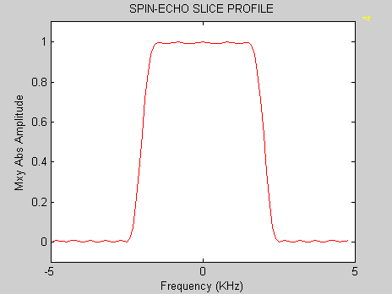 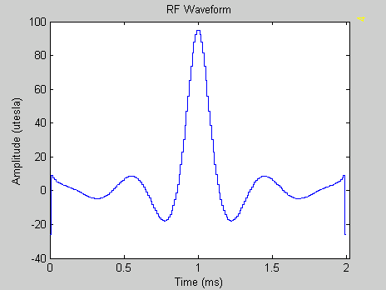

Fig. 1. Crushed SE magnitude profile. Fig. 2. SE pulse.

To excite a 10 cm slab, the gradient used with the pulse would be approximately 1 mT. While the pulse can be remapped (MatPulse version of VERSE) to shorten the pulse duration to under 2 ms (Fig. 3) (to enable the pulse plus crusher gradients to be within approximately 2 ms), the gradient must be drooped to about 0.2 mT/m to bring the B1max to within 20 T (Fig. 4). This causes some distortion in the profile when a resonance offset of 100 Hz is used in the Bloch Equations menu to graph the B2 G2 SE magnitude crushed pulse profile (Fig. 5).

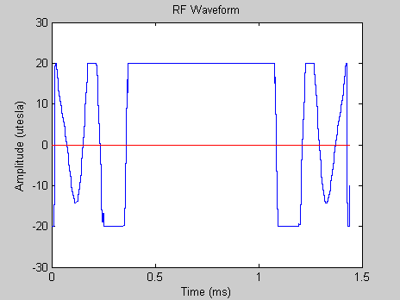 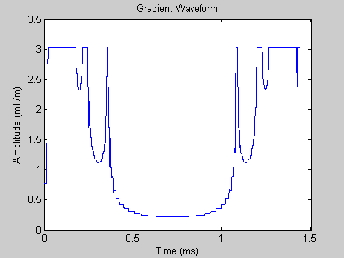 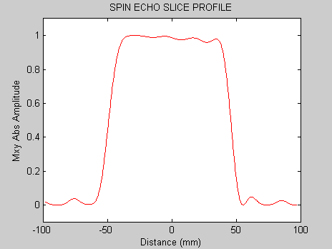

Fig. 3. Remapped SE pulse. Fig. 4. Remapped gradient. Fig. 5. SE pulse profile at 100Hz offset.

At this point, there are several possible approaches. First, the pulse may be used as is, as the distortions (Fig. 5) are not large. Second, we may attempt to have the pulse root reflected to reduce the B1max prior to being remapped. Figure 6 shows the root being reflected by the MatPulse Root Reflection menu, and Fig. 7 shows the new SE pulse with B1max lowered to about 60 T. However, Fig. 8 demonstrates that the remapping does not succeed in reducing the pulse duration below 2 ms. That is because, although the B1max has been lowered, the amplitude over much of the rest of the pulse has been increased by the root reflection, so that the remapping is now much less effective in reducing the length of the pulse.

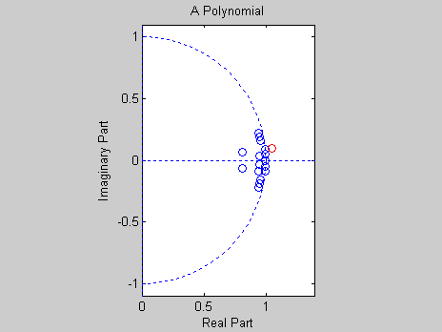 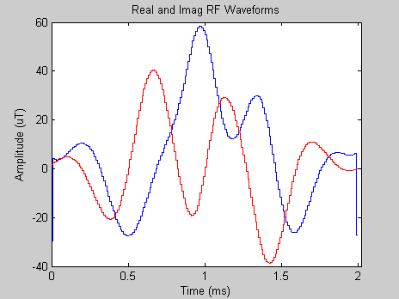 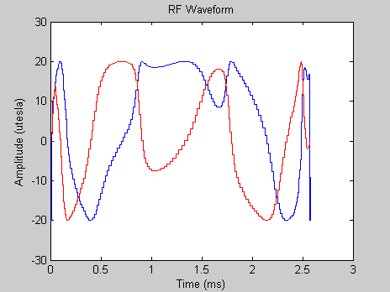

Fig. 6. Root being reflected. Fig. 7. Root reflected SE pulse. Fig. 8. Remapped pulse of Fig. 7.

A third possibility is to use three concatenated 60 degree pulses to perform as a single SE pulse. Frequency selective pulses accompanied by their defocusing and refocusing gradients can be concatenated to produce accumulated tipping. However, it is more efficient to use gradients of alternating sign to cancel the defocusing and refocusing gradients within the cascade. Figure 9A shows a cascade of three 60 degree pulses to form a single SE pulse. Figures 9B and 9C show graphically that the cascade without the leading defocusing and trailing refocusing gradients may be considered to be a single SE pulse with the crusher gradient incorporated into the cascade.



Fig. 9. (A) Concatenated SE pulse. (B) SE pulse with crusher gradients added. (C) Effective SE pulse with crusher gradients incorporated.

Figure 10 shows a 200 point, 60 degree SLR pulse with a width of 4 kHz and a duration of 2 ms. The B1max of this pulse is well under 20 T. With this pulse in the MatPulse workspace, the Concatenation menu may be used to generate the kind of concatenation shown in Fig. 9C, with a gradient magnitude of 1 mT/m. The concatenated pulse and gradient waveforms are shown in Figs. 11 and 12, respectively.

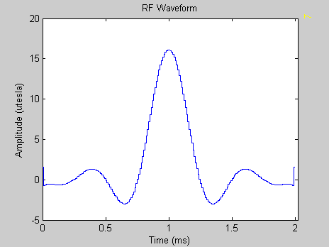 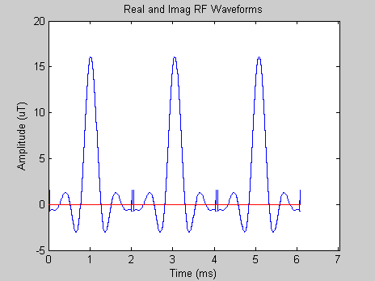 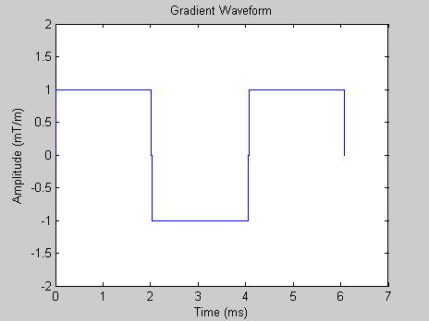

Fig. 10. 60 degree pulse. Fig. 11. Cascaded pulses. Fig. 12. Cascaded gradient waveform.

The magnitude SE profiles from the Bloch equations (B2, G2 magnitude crushed spin echo profile) shows the cascaded sequence does perform as a SE pulse, but the pulse is much too long and the profile is markedly reduced even with a resonance offset of just 50 Hz (Fig. 14).

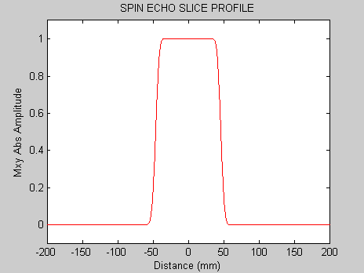 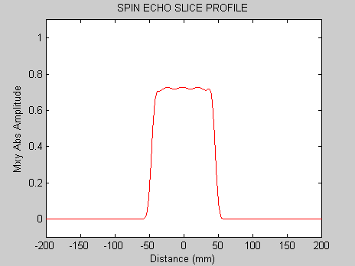

Fig. 13. Cascaded SE pulse profile at 0 Hz offset. Fig. 14. Cascaded SE pulse profile at 50 Hz offset.

**Final Pulse Design:**

If the 60 degree pulse of Fig. 10 is remapped with a Gmax of 5, it is shortened to under 6 ms (Figs. 15 and 16).

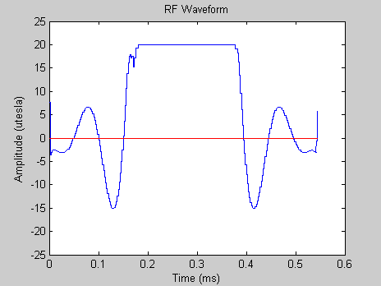 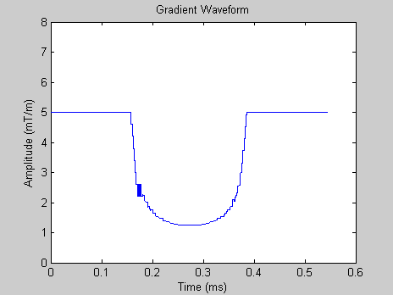

Fig. 15. Remapped 60 degree pulse Fig 16. Remapped gradient waveform.

((Unfortunately, the Concatenate menu does not currently work with B2 G2 pulses as inputs, and the concatenation of the B2 pulses and G2 gradients of Figs. 15 and 16 must be done with a text editor, such as pfe.)) Doing the concatenation in pfe yields the concatenated pulse (Fig. 17) and gradient waveform (Fig. 18). The 0 Hz off-resonance and 100 Hz off-resonance crushed magnitude SE profiles from the Block Equations are shown in Figures 19 and 20.

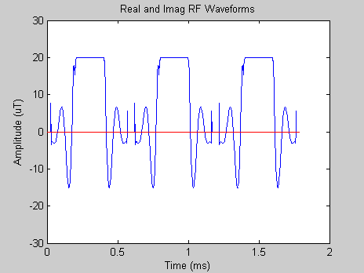 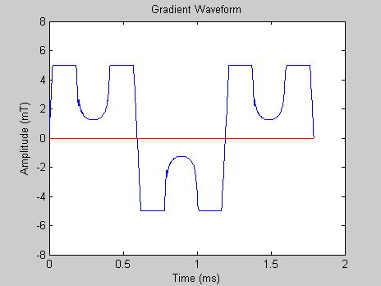

Fig. 17. Cascaded, remapped 60 degree pulses. Fig. 18. Gradient waveform for pulse of Fig. 17.

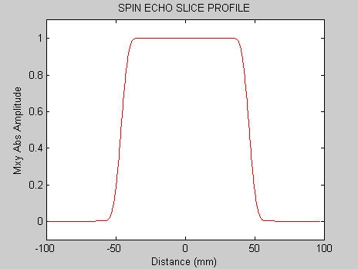 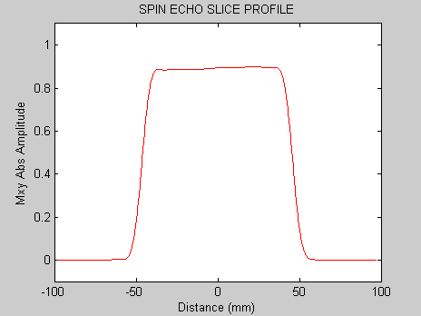

Fig. 19. SE magnitude profile at 0 Hz resonance offset. Fig. 20. SE magnitude profile at 100 Hz resonance offset.

As shown by Figs. 19 and 20, the spin echo profile at 0 Hz resonance offset is excellent. While the profile at 100 Hz resonance offset shows some reduction in signal intensity, it does not show the profile degradation exhibited by Fig. 5. In addition, the total length of the pulse plus crusher gradients is well under 2 ms, as the crusher gradients are now incorporated into the concatenated pulse and gradient waveforms.